***TRY MORE UNUSUAL PLANTS***

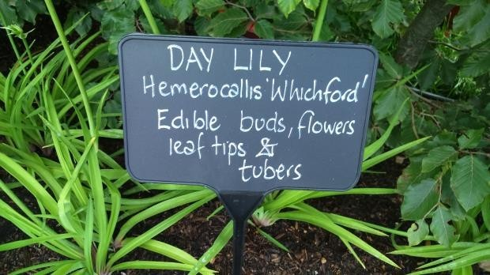

Daylilies create drama in the garden and provide food

I love trying out new edibles – both to see how they grow and to experiment in the kitchen. Some of my new acquisitions this year include hardy ginger (Zingiber mioga with edible young shoots and flowerbuds) and Caucasian spinach (Hablizia tamnoides with spinach-like leaves). Juliet has included bamboo, hostas, daylilies and ferns in her garden with useful tips on growing and cooking with them on the labels.

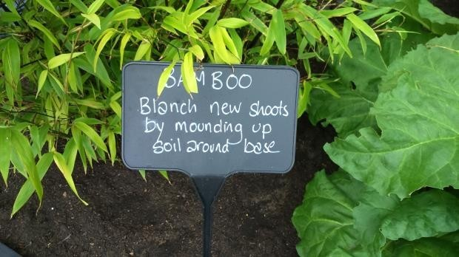

If you already have bamboo in the garden, this snack should be easy to come by.